- Required Files/Software
*Download dfu-prog-usb-1.2.2.zip file and extract.
*Download 02D_KeyMapper_Custom_v1.5.333.exe file and move into the dfu-prog-usb-1.2.2 folder.
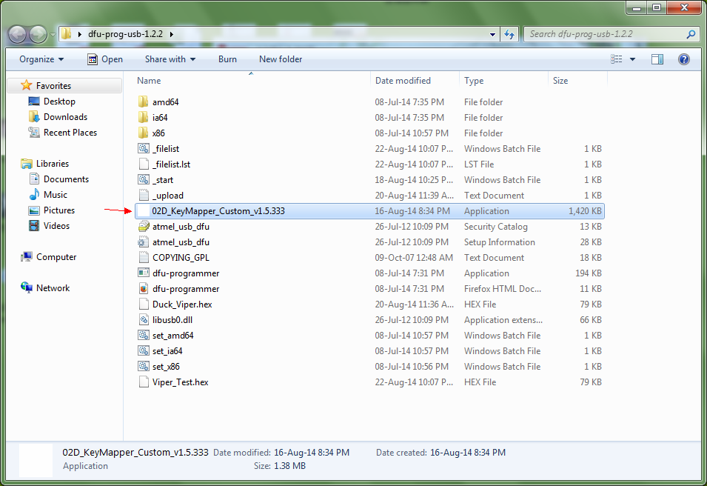
*Both dfu-prog-usb-1.2.2.zip and 02D_KeyMapper_Custom_v1.5.333.exe files can be found at EC QQ group sharing.
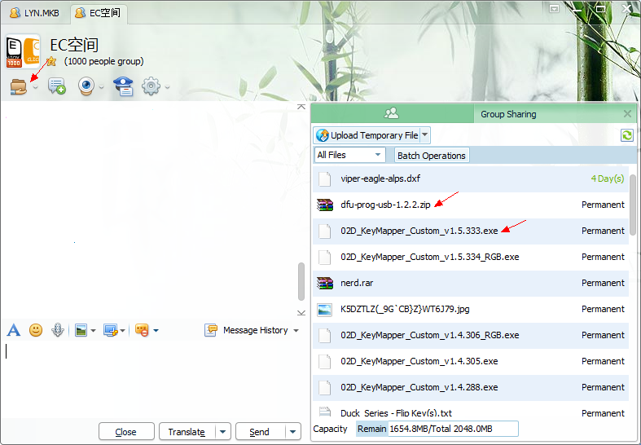

- Keymapping with 02D software
*Open 02D_KeyMapper_Custom_v1.5.333.exe file and select a new 02D custom firmware to start your keymapping accordingly.
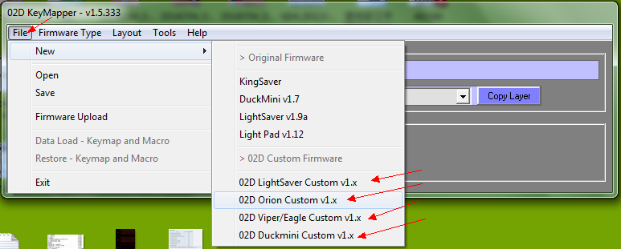
*Taking Duck Viper as example:
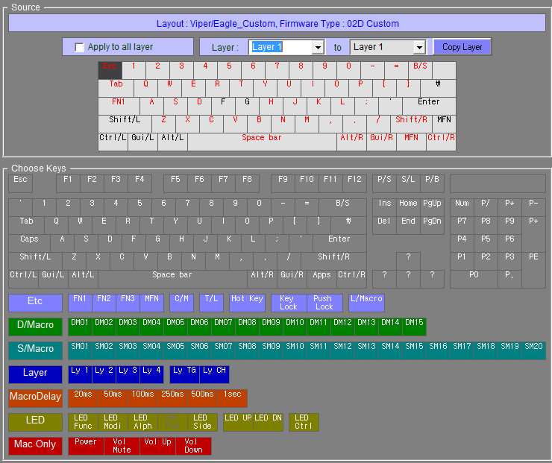
*After keymapping done, just save your .hex file for flashing firmware later on. You can rename the file for easier to refer later on.
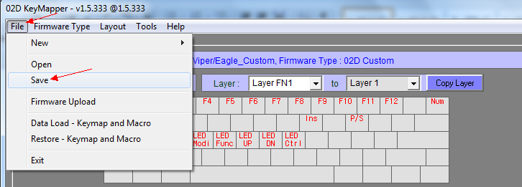
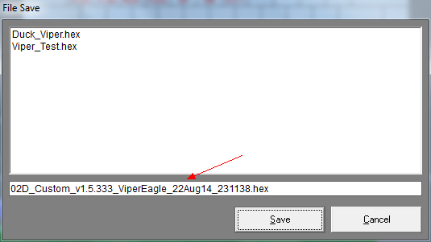
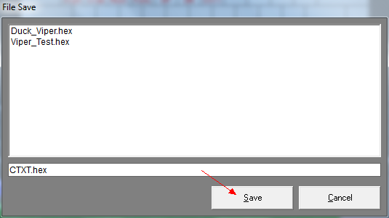
*You can always open your existing .hex file and edit accordingly.
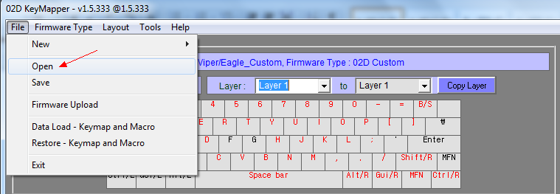
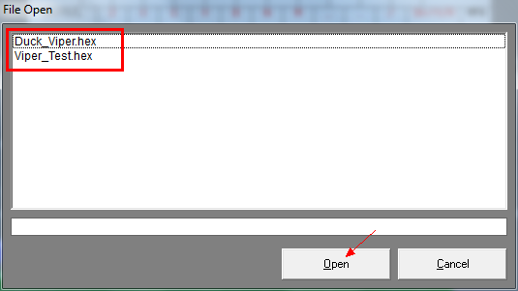
*For more info, you can download the 02D Software User Manual at EC group sharing. If cannot understand, just play or trial&error with the software you will know those functions eventually. I only able do the simple keymapping that fit my preference/purpose. Hardware Macro setting and other new functions I am not sure how to use them either.
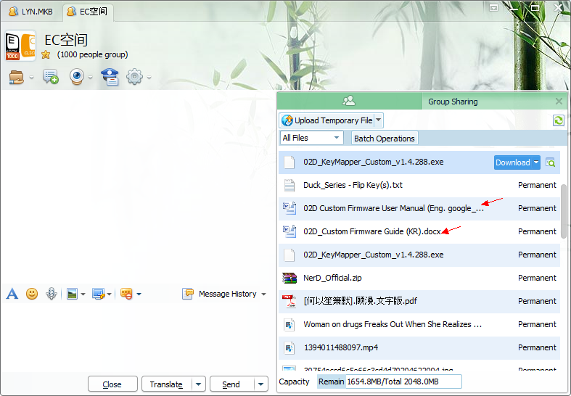
*However, there is one bug that I have for arrow keys setting but some people are not having this bug. As you can see the picture below, the arrow keys are shown as “?”. After u set on the “?” arrow keys on some of your layers, the data entry wont be recorded even u have saved the .hex file.
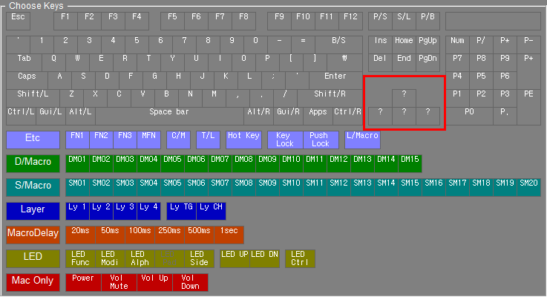
*To overcome this issue, I just use a temporary solution by mapping the arrow keys with number pad keys: P8, P4, P6 and P2. At the same time, set a NumLock and turn it off.
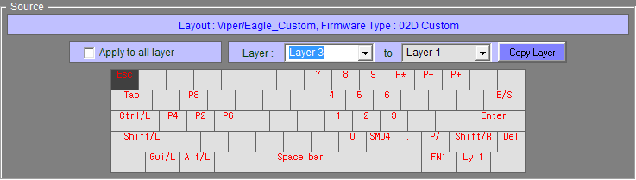
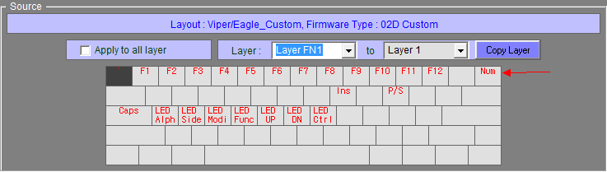

- Flash Firmware
*Before connecting your PCB to your PC USB port, press and hold the FLIP key:
KingSaver = "Esc"
Mini, Viper/Eagle = "Capslock"
LightSaver = "Right Key on top of Backspace"
LightPad = "Most Top Left Key"
*Pop out message detecting unsuccessful installation of usb hardware.
*Open “Device Manager” find the usb device that is not installed properly.
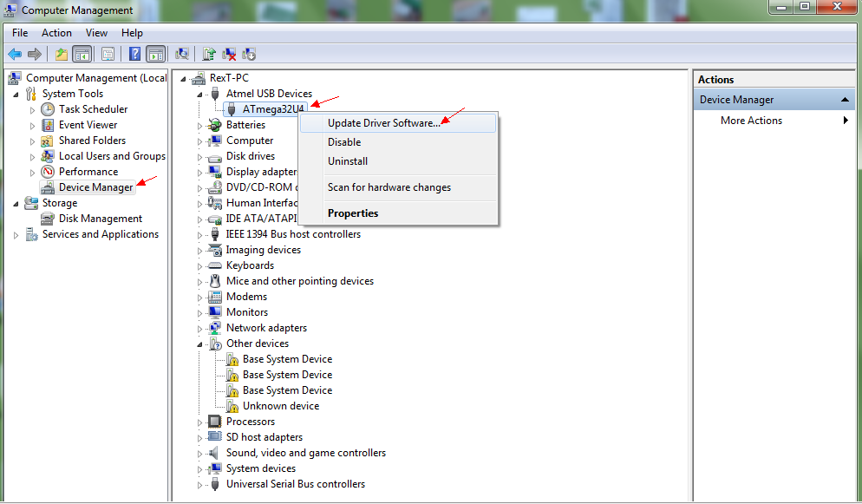
*Manually update this usb device by browsing " dfu-prog-usb-1.2.2 " folder and click ok.
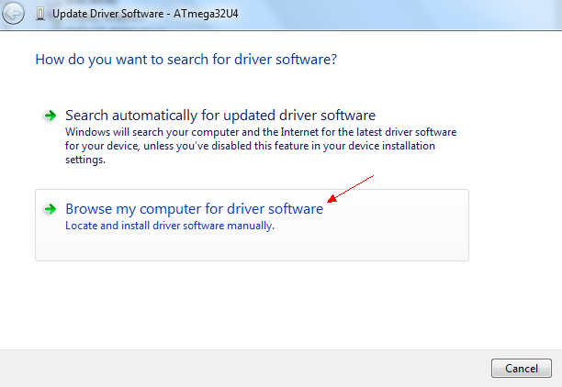
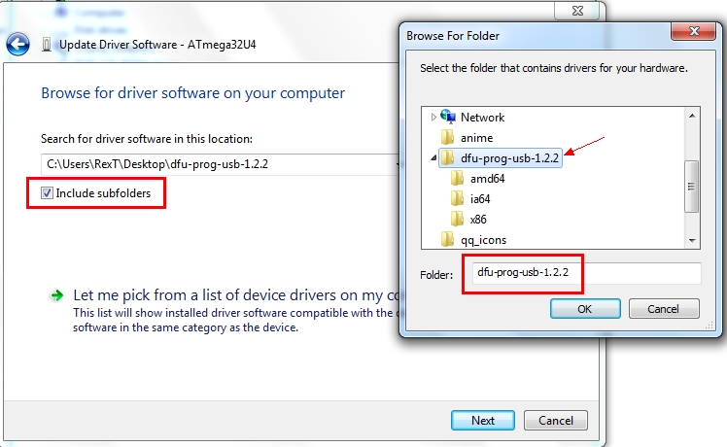
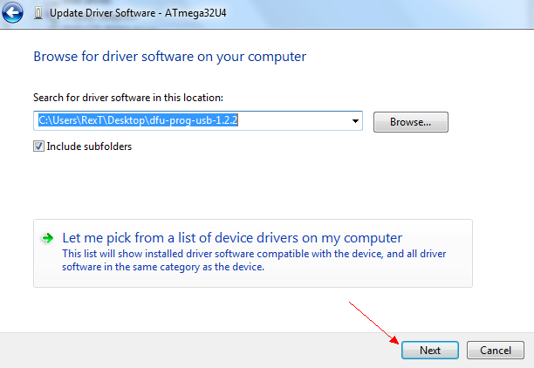
*Next is uploading the the hex file and flashing the firmware.
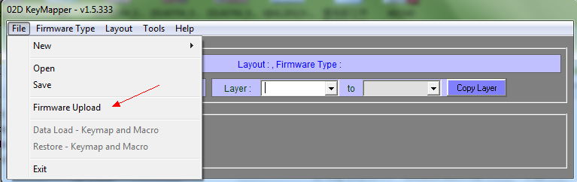
*Click “Connect” to make sure again that keyboard is detected. After that click “File Open” and select the hex file you wish to upload.
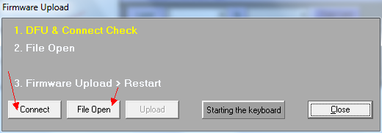
*After file is selected, click “Upload” and a command window will pop out to start flashing the firmware. When flash firmware is done, press any key to quit and enjoy your keyboard.


