- First, if don’t have chrome yet, install chrome. Then, install the tkg.io addon for chrome, link here: https://chrome.google.com/webstore/detail/tkg-chrome-app/kmbmjdabhpdnpeobnbdchihdcdaccidi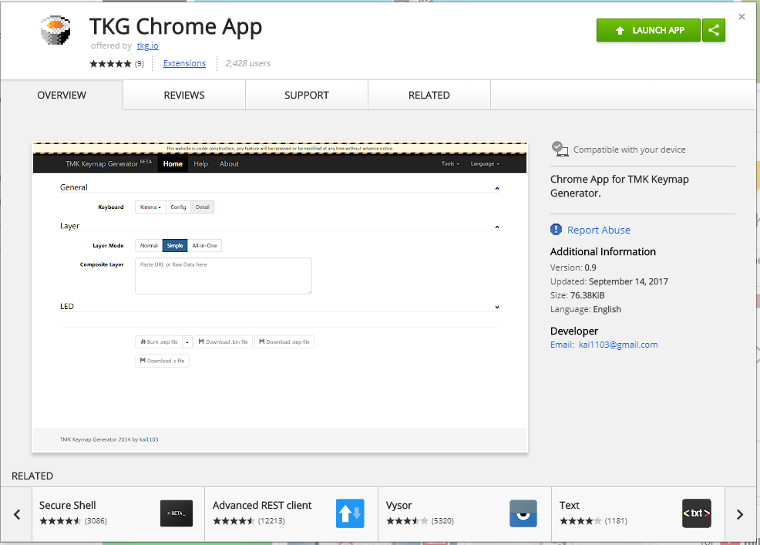

- Install Zadig 2.3 from this link: https://drive.google.com/drive/folders/1rDQhwKfjRVQxS5aDd2SKaFo8yoDeFe5n
It’s located in the DFU_Driver folder.
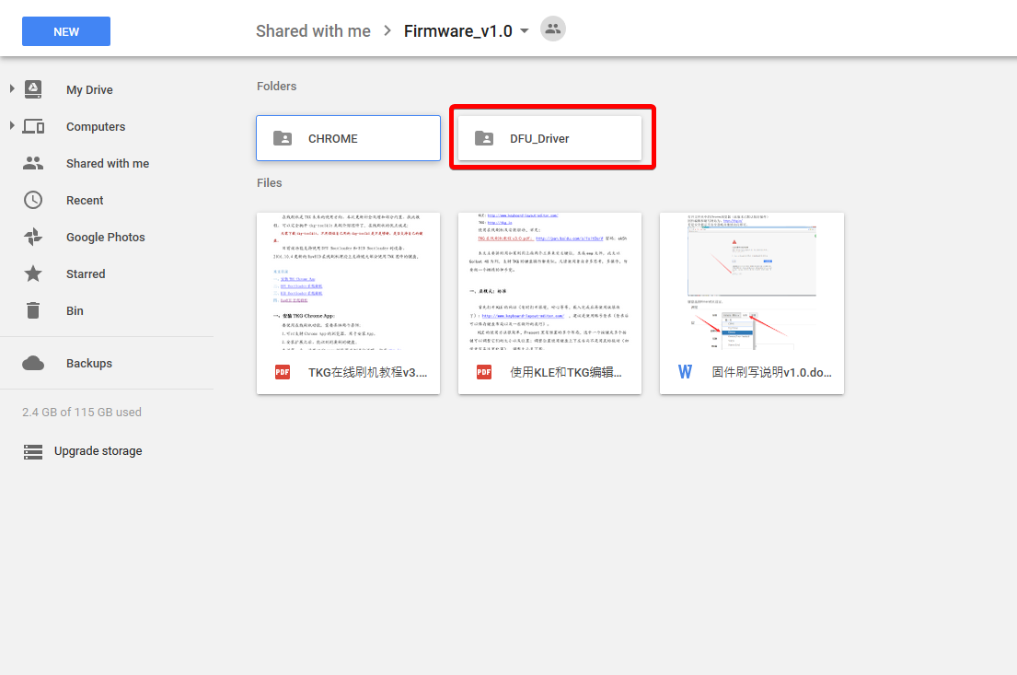

- If you haven’t soldered your USB cables yet, here is a quick guide: 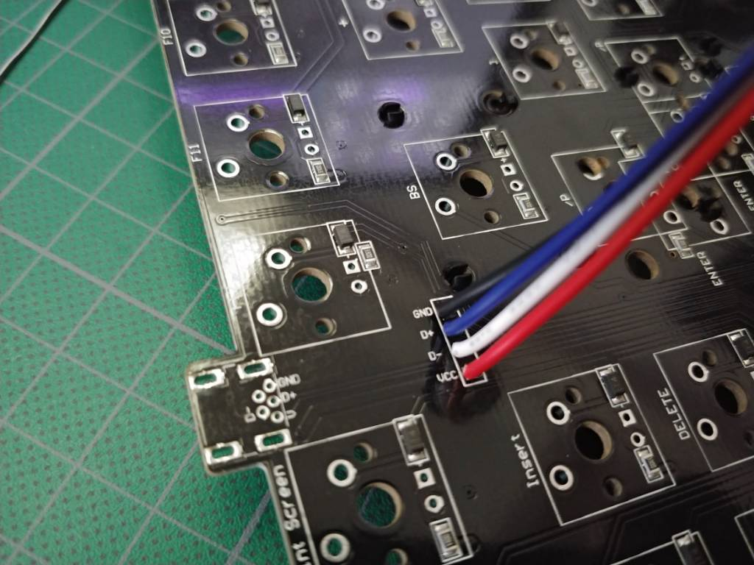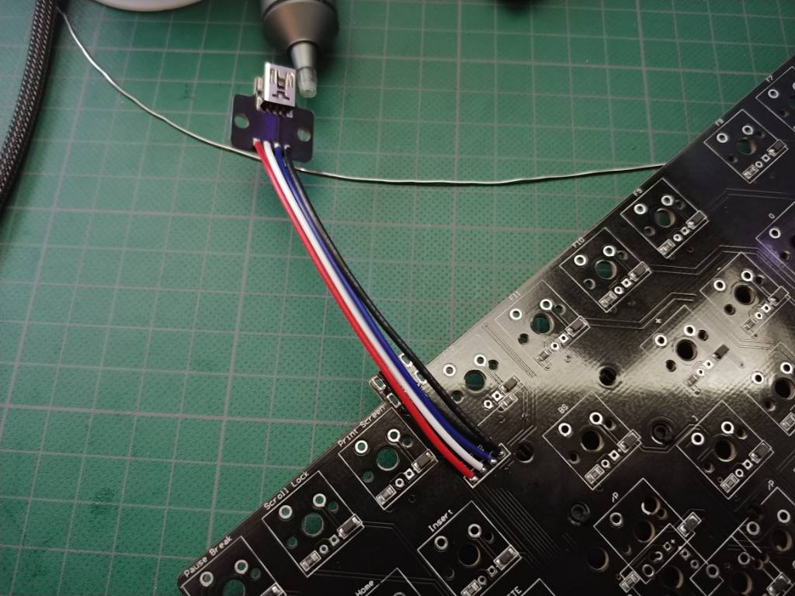

- Plug the usb in your pc, and make sure there are no drivers installed. If there are, or if you are not sure, right click the windows icon in the bottom left on your pc, select device manager: 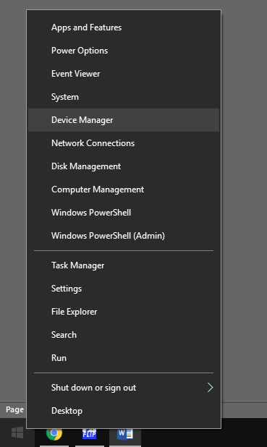

Then look for ATm32U4DFU. If you see that, leave device manager and open Zadig.
If you do not see that, look for ATM32U4 or ATmega32u4. Right click it and click uninstall device, and make sure to check the ‘also delete drivers’ box.
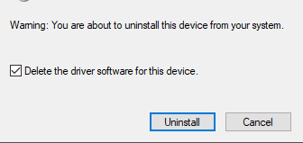

- With Zadig opened, make sure the windows looks like this, with ATm32U4DFU selected.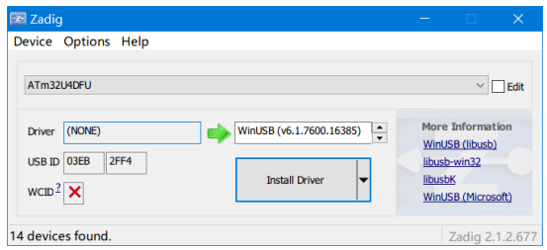
If you don’t see ATm32U4DFU selected and can’t find it in the drop down box, go to options and select list all devices:
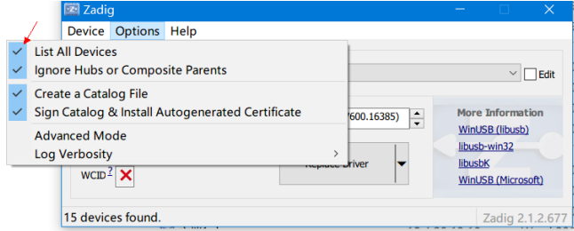
Click on install driver and wait for the ‘the driver was installed successfully’ popup then close Zadig.

- Now, go to tkg.io and on the top select ‘Kimera’. Then, click on config next to is and select custom.
Make sure the row mapping has the boxes 1 – 8 in them, and the col mapping has 20-30 in them.
In the matrix mapping box, paste one of these codes, depending if you need ANSI or ISO:
For ANSI:
["1,1",{x:1},"1,2","1,3","1,4","1,5",{x:0.5},"1,6","1,7","1,8","1,9",{x:0.5},"1,10","1,11","7,1","7,2",{x:0.25},"7,3","7,4","7,5"],
[{y:0.5},"2,1","2,2","2,3","2,4","2,5","2,6","2,7","2,8","2,9","2,10","2,11","7,6","7,7",{w:2},"7,8",{x:0.25},"7,9","7,10","7,11"],
[{w:1.5},"3,1","3,2","3,3","3,4","3,5","3,6","3,7","3,8","3,9","3,10","3,11","8,1","8,2",{w:1.5},"8,3",{x:0.25},"8,4","8,5","8,6"],
[{w:1.75},"4,1","4,2","4,3","4,4","4,5","4,6","4,7","4,8","4,9","4,10","4,11","8,7",{w:2.25},"8,8"],
[{w:2.25},"5,1","5,3","5,4","5,5","5,6","5,7","5,8","5,9","5,10","5,11","8,9",{w:2.75},"8,11",{x:1.25},"8,10"],
[{w:1.25},"6,1",{w:1.25},"6,2",{w:1.25},"6,3",{w:6.25},"6,4",{w:1.25},"6,5",{w:1.25},"6,6",{w:1.25},"6,7",{w:1.25},"6,8",{x:0.25},"6,9","6,10","6,11"]

For ISO:

["1,1",{x:1},"1,2","1,3","1,4","1,5",{x:0.5},"1,6","1,7","1,8","1,9",{x:0.5},"1,10","1,11","7,1","7,2",{x:0.25},"7,3","7,4","7,5"],
[{y:0.5},"2,1","2,2","2,3","2,4","2,5","2,6","2,7","2,8","2,9","2,10","2,11","7,6","7,7",{w:2},"7,8",{x:0.25},"7,9","7,10","7,11"],
[{w:1.5},"3,1","3,2","3,3","3,4","3,5","3,6","3,7","3,8","3,9","3,10","3,11","8,1","8,2",{x:0.25,w:1.25,h:2,w2:1.5,h2:1,x2:-0.25},"8,8",{x:0.25},"8,4","8,5","8,6"],
[{w:1.75},"4,1","4,2","4,3","4,4","4,5","4,6","4,7","4,8","4,9","4,10","4,11","8,7","8,3"],
[{w:1.25},"5,1","5,2","5,3","5,4","5,5","5,6","5,7","5,8","5,9","5,10","5,11","8,9",{w:2.75},"8,11",{x:1.25},"8,10"],
[{w:1.25},"6,1",{w:1.25},"6,2",{w:1.25},"6,3",{w:6.25},"6,4",{w:1.25},"6,5",{w:1.25},"6,6",{w:1.25},"6,7",{w:1.25},"6,8",{x:0.25},"6,9","6,10","6,11"]

After entering the code the border of the matrix mapping box should turn green. If it turns red, make sure you have the right amount of rows and collums noted above.
Now you should have something similar to this: 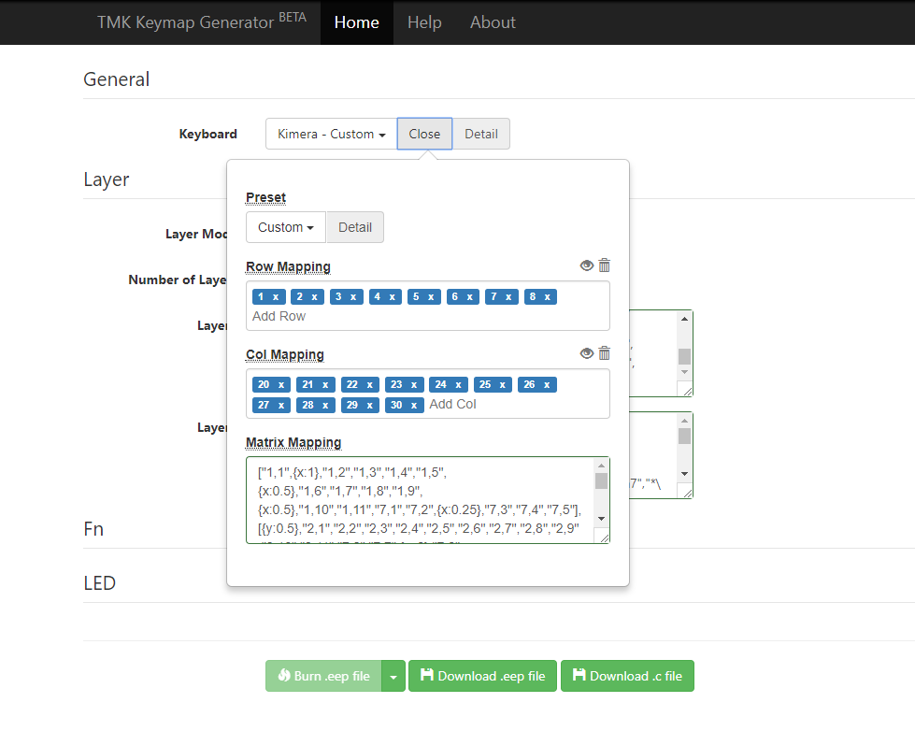

Click on close next to kimera – custom, and continue to the next step.

- Make sure normal is selected in layer mode, and the number of layers is set to 2.

Then paste the following codes, depending if you need ANSI or ISO:

ANSI
Layer0:
["Esc",{x:1},"F1","F2","F3","F4",{x:0.5},"F5","F6","F7","F8",{x:0.5},"F9","F10","F11","F12",{x:0.25},"PrtSc","Scroll Lock","Pause\nBreak"],
[{y:0.5},"~\n`","!\n1","@\n2","#\n3","$\n4","%\n5","^\n6","&\n7","*\n8","(\n9",")\n0","_\n-","+\n=",{w:2},"Backspace",{x:0.25},"Insert","Home","PgUp"],
[{w:1.5},"Tab","Q","W","E","R","T","Y","U","I","O","P","{\n[","}\n]",{w:1.5},"|\n\\",{x:0.25},"Delete","End","PgDn"],
[{w:1.75},"Caps Lock","A","S","D","F","G","H","J","K","L",":\n;","\"\n'",{w:2.25},"Enter"],
[{w:2.25},"Shift","Z","X","C","V","B","N","M","<\n,",">\n.","?\n/",{w:2.75},"rShift",{x:1.25},"↑"],
[{w:1.25},"Ctrl",{w:1.25},"Win",{w:1.25},"Alt",{a:7,w:6.25},"space",{a:4,w:1.25},"rAlt",{w:1.25},"fn0",{w:1.25},"Menu",{w:1.25},"rCtrl",{x:0.25},"←","↓","→"]

Layer1:
["Esc",{x:1},"F1","F2","F3","F4",{x:0.5},"F5","F6","F7","F8",{x:0.5},"F9","F10","F11","F12",{x:0.25},"PrtSc","Scroll Lock","Pause\nBreak"],
[{y:0.5},"~\n`","!\n1","@\n2","#\n3","$\n4","%\n5","^\n6","&\n7","*\n8","(\n9","fn1","fn2","fn3",{w:2},"Backspace",{x:0.25},"Insert","Home","PgUp"],
[{w:1.5},"Tab","Q","W","E","R","T","Y","U","I","O","P","{\n[","}\n]",{w:1.5},"fn3",{x:0.25},"Delete","End","PgDn"],
[{w:1.75},"Caps Lock","A","S","D","F","G","H","J","K","L",":\n;","\"\n'",{w:2.25},"Enter"],
[{w:2.25},"Shift","Z","X","C","V","B","N","M","<\n,",">\n.","?\n/",{w:2.75},"rShift",{x:1.25},"↑"],
[{w:1.25},"Ctrl",{w:1.25},"Win",{w:1.25},"Alt",{a:7,w:6.25},"space",{a:4,w:1.25},"rAlt",{w:1.25},"fn0",{w:1.25},"Menu",{w:1.25},"rCtrl",{x:0.25},"←","↓","→"]

ISO:
Layer0:
["Esc",{x:1},"F1","F2","F3","F4",{x:0.5},"F5","F6","F7","F8",{x:0.5},"F9","F10","F11","F12",{x:0.25},"PrtSc","Scroll Lock","Pause\nBreak"],
[{y:0.5},"¬\n`","!\n1","\"\n2","£\n3","$\n4","%\n5","^\n6","&\n7","*\n8","(\n9",")\n0","_\n-","+\n=",{w:2},"Backspace",{x:0.25},"Insert","Home","PgUp"],
[{w:1.5},"Tab","Q","W","E","R","T","Y","U","I","O","P","{\n[","}\n]",{x:0.25,w:1.25,h:2,w2:1.5,h2:1,x2:-0.25},"Enter",{x:0.25},"Delete","End","PgDn"],
[{w:1.75},"Caps Lock","A","S","D","F","G","H","J","K","L",":\n;","@\n'","~\n#"],
[{w:1.25},"Shift","|\n\\","Z","X","C","V","B","N","M","<\n,",">\n.","?\n/",{w:2.75},"rShift",{x:1.25},"↑"],
[{w:1.25},"Ctrl",{w:1.25},"Win",{w:1.25},"Alt",{a:7,w:6.25},"space",{a:4,w:1.25},"rAlt",{w:1.25},"fn0",{w:1.25},"Menu",{w:1.25},"rCtrl",{x:0.25},"←","↓","→"]

Layer1:
["Esc",{x:1},"F1","F2","F3","F4",{x:0.5},"F5","F6","F7","F8",{x:0.5},"F9","F10","F11","F12",{x:0.25},"PrtSc","Scroll Lock","Pause\nBreak"],
[{y:0.5},"¬\n`","!\n1","\"\n2","£\n3","$\n4","%\n5","^\n6","&\n7","*\n8","(\n9","fn1","fn2","fn3",{w:2},"Backspace",{x:0.25},"Insert","Home","PgUp"],
[{w:1.5},"Tab","Q","W","E","R","T","Y","U","I","O","P","{\n[","}\n]",{x:0.25,w:1.25,h:2,w2:1.5,h2:1,x2:-0.25},"Enter",{x:0.25},"Delete","End","PgDn"],
[{w:1.75},"Caps Lock","A","S","D","F","G","H","J","K","L",":\n;","@\n'","~\n#"],
[{w:1.25},"Shift","|\n\\","Z","X","C","V","B","N","M","<\n,",">\n.","?\n/",{w:2.75},"rShift",{x:1.25},"↑"],
[{w:1.25},"Ctrl",{w:1.25},"Win",{w:1.25},"Alt",{a:7,w:6.25},"space",{a:4,w:1.25},"rAlt",{w:1.25},"fn0",{w:1.25},"Menu",{w:1.25},"rCtrl",{x:0.25},"←","↓","→"]

Now you should have something like this:

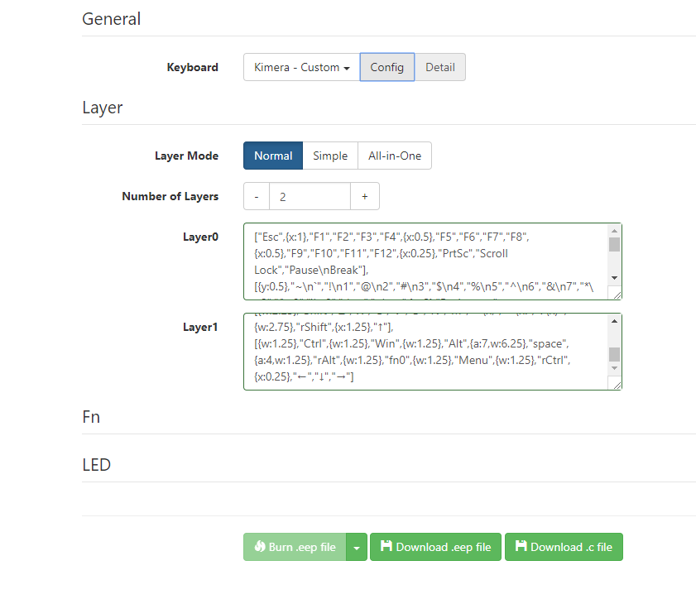

- Finally, with the keyboard plugged in and press the drop down window next to burn .eep file, and select ATm32U4DFU, and it will install the firmware for you:

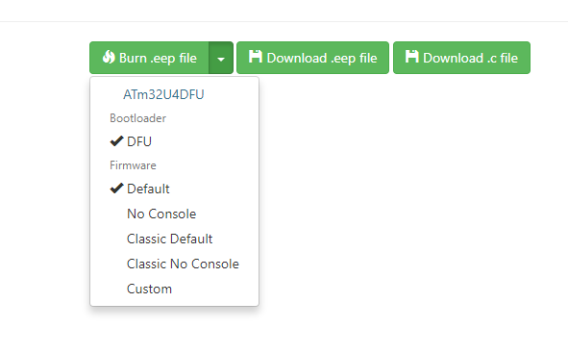
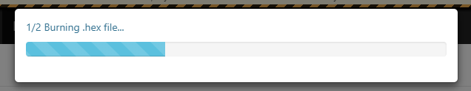

And that’s it! Your keyboard should (finally) be working now!

Please note: This is just for the basic TKL layout, so you can check if all your keys are working. This is as far as I got with figuring this out, so if I know how to edit in custom keymaps to certain keys, I will do a short guide on that as well.

