- 套件内含 Includes

亚克力底座
键盘主体、U2U及固定支架

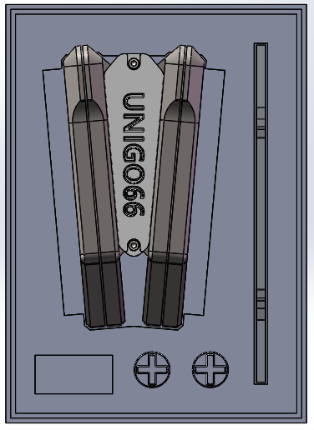
二合一拔轴、拔键器
备用凯华热拔插元件
备用螺丝铜柱等
防滑脚贴
卫星轴插件
简易M2、M3六角扳手
底座支架

- 包装拆解及使用说明Packaging disassembly and instructions for use
  - 拆除顶部螺丝并取下顶部固定件即可完成键盘主体及包装分解，期间注意防止键盘本体掉落。
Remove the top screw and the top 3D-printing part to disassemble the keyboard and package, and take care to prevent the keyboard body from falling.
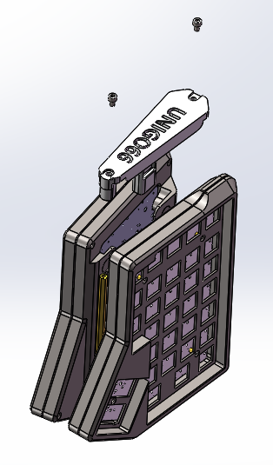
  - 拆解本体底部螺丝拆卸键盘底壳，进行电池安装。
Disassemble the bottom screw of the keyboard to remove the bottom case for battery installation.
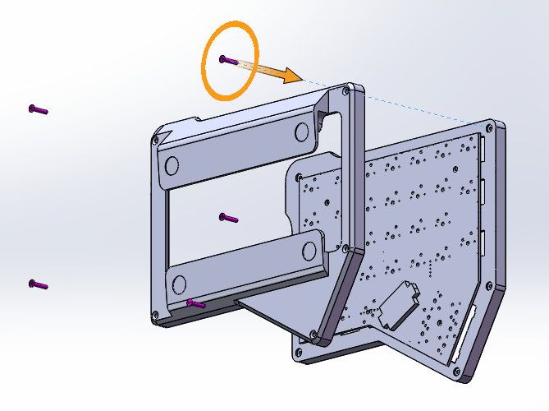
电池盒
Battery holder
  - 电池的拆装 Battery installation
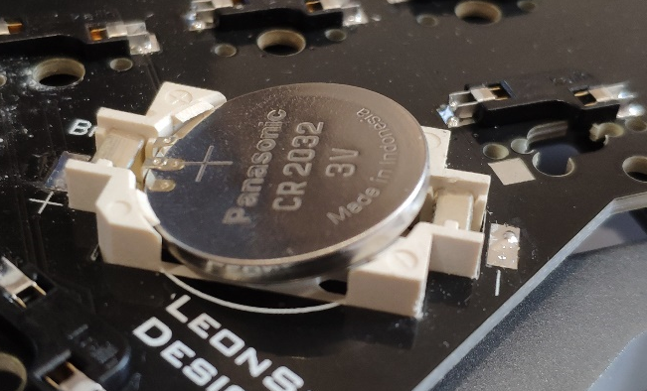
电池安装时如上图，先插入顶部有触点一面再将另一面按入，注意切勿太过用力，以防损坏电池座焊点。
Install the battery as shown above, first insert the side with the contact and then press the other side, be careful not to use too much force to prevent damage to the battery holder solder joint.

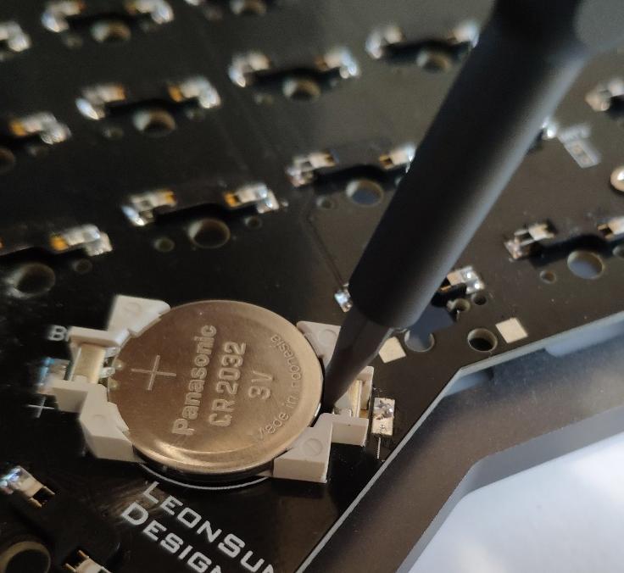
电池拆卸时如上图，使用螺丝刀或其余工具插入此处间隙中将电池挑出，请勿用力拆卸。
Uninstall the battery shown above, use a screwdriver or other tools to insert the gap of the battery holder and get the battery off, be careful not to use too much force.

  - 电源开关位于正面键盘正面，往下为开，往上为关
The power switch is located on the front keyboard, down for on, up for off.
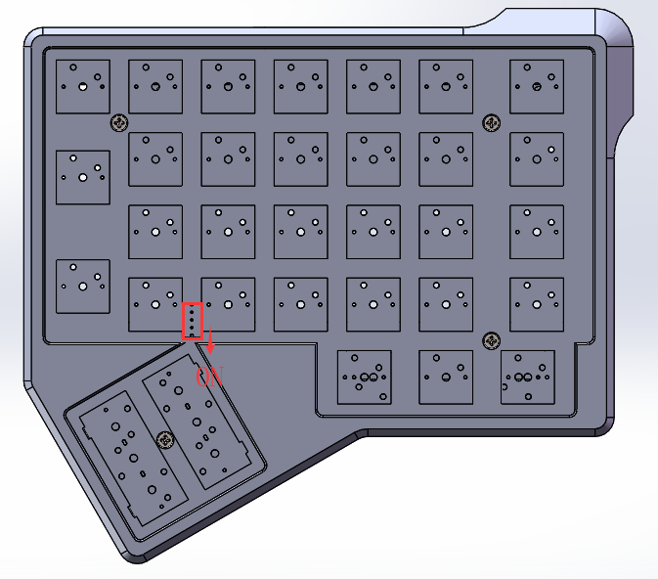

  - 当拇指位置需要使用2U钢板卫星轴时，可使用卫星轴附件增加稳定性，安装方式如下：
When you want to use the 2U stabs for the thumb position, you can install the 3D-printing accessories for stability. The installation method is as follows:
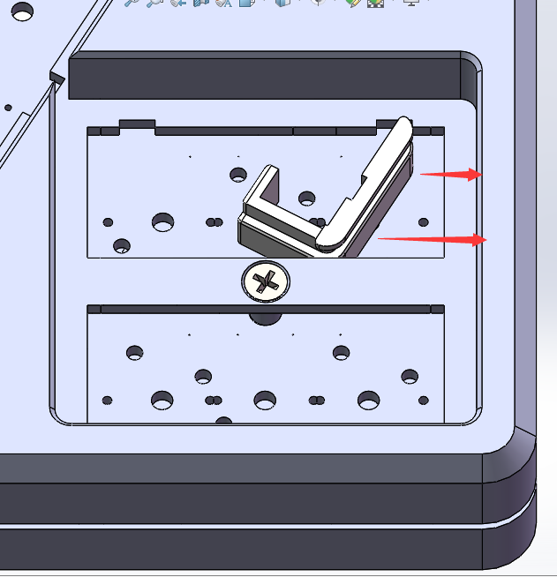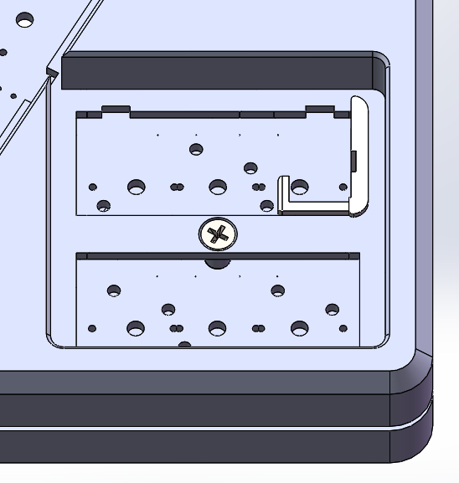

  - 支架陈列模式装配方式如下，支架底座卡入脚架即可
The display mode is assembled as follows.
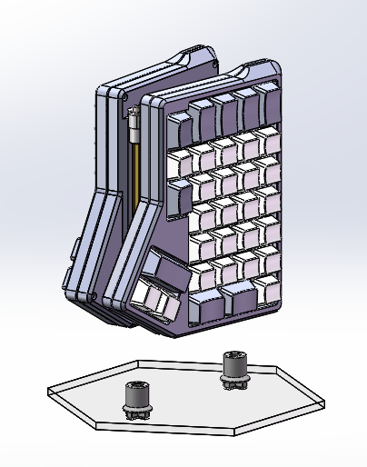

  - 如何使U2U进入DFU刷机模式
How to get U2U into DFU flashing mode
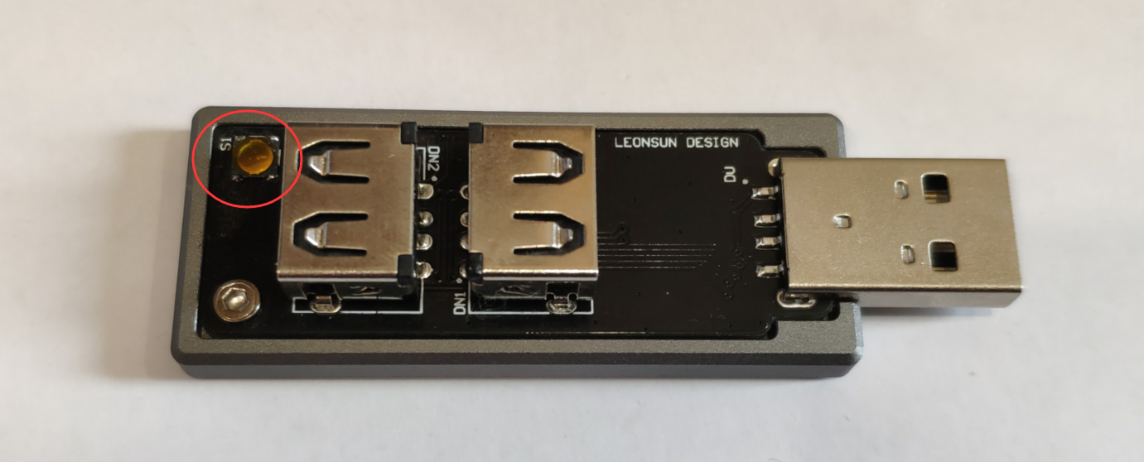
将U2U插入电脑并按下图中红圈位置微动，即可进入DFU刷机模式
Insert U2U into the computer and press the bottom in the red circle shown in the figure, and U2U will enter DFU mode.

  - UniGo66默认配列 Default layout
到手通电后默认配列如下，需另外修改配列请见刷机说明：
The default layout is as follows, go to the flashing instruction if you want to change.

Layer0
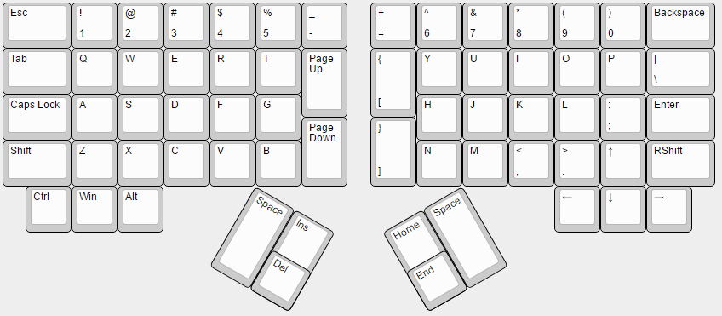
与Rshift一同使用为？键
Output ? when press with Rshift
单击为空格键，按住切换至layer1，双击第二下按住为持续输出空格
Click as space bar, press and hold to switch to layer1, double-click and hold to continually output spaces

与Rshift一同使用为“键
Output “ when press with Rshift

Layer1
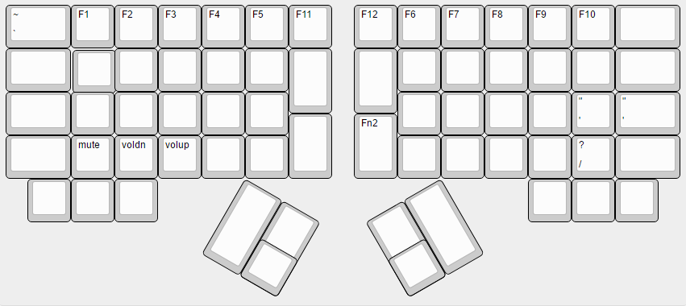
点击开启Layer2
Press to turn Layer2 On

Layer2
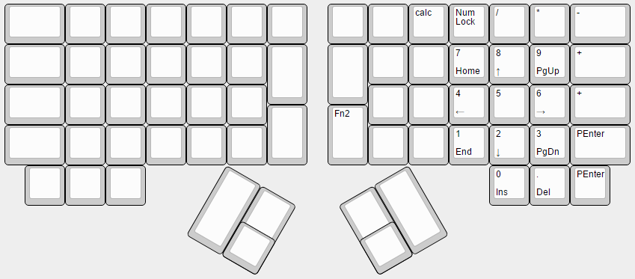
点击关闭Layer2
Press to turn Layer2 Off

