Cherry G80-2551
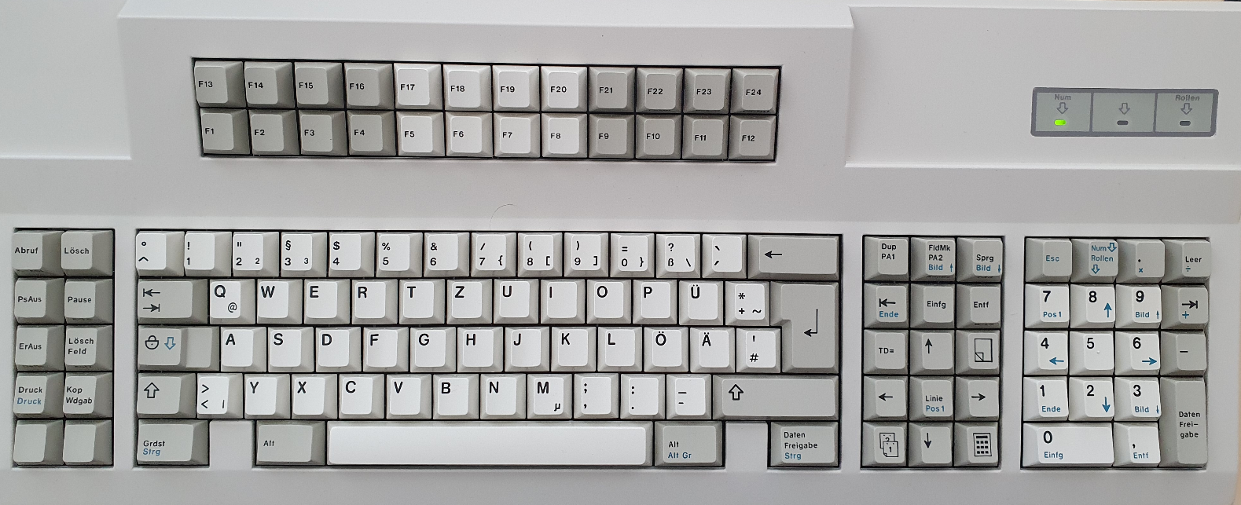
10 function keys on left cluster
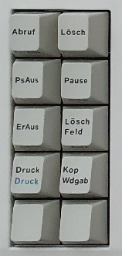 | r19 rF0 r19 | r5F rF0 r5F
 | r39 ^[[2~rF0 r39 | rE1 r14 r77 rE1 rF0 r14 rF0 r77
 | r^[[D53 rF0 r53 | r50 rF0 r50
 | rE0 r12 rE0 r7C rE0 rF0 r7C rE0 rF0 r12 | r6F rF0 r6F
 | r5C rF0 r5C | r48 rF0 r48

Nav cluster
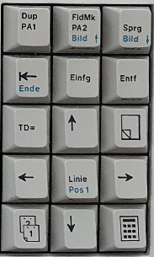
r17 rF0 r17 | rE0 r12 rE0 r^[[5~7D rE0 rF0 r7D rE0 rF0 r12 | rE0 r12 rE0 ^[[6~r7A rE0 rF0 r7A rE0 rF0 r12
rE0 r12 rE0 r69 ^[[FrE0 rF0 r69 rE0 rF0 r12 | rE0 r12 rE0 r70 ^[[2~rE0 rF0 r70 rE0 rF0 r12 | rE0 r12 rE0 r71 ^[[3~rE0 rF0 r71 rE0 rF0 r12
r80 r26 r80 rF0 r26 | rE0 r12 rE0 r75 ^[[ArE0 rF0 r75 rE0 rF0 r12 | r80 r25 r80 rF0 r25
rE0 r12 rE0 r^[[D6B rE0 rF0 r6B rE0 rF0 r12 | rE0 r12 rE0 r6C ^[[HrE0 rF0 r6C rE0 rF0 r12 | rE0 r12 rE0 r74 ^[[CrE0 rF0 r74 rE0 rF0 r12
r80 r16 r80 rF0 r16 | rE0 r12 rE0 ^[[Br72 rE0 rF0 r72 rE0 rF0 r12 | r80 r1E r80 rF0 r1E

F-block
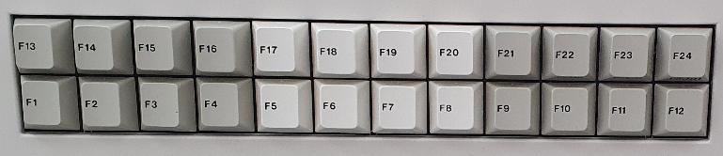
left
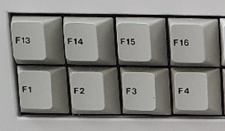 | r1F rF0 r1F | r27 ^[[FrF0 r27 | r^[[H2F rF0 r2F | r5E ^[[5~rF0 r5E
 | r^[OP05 rF0 r05 | r^[OQ06 rF0 r06 | r^[OR04 rF0 r04 | r^[OS0C rF0 r0C

middle
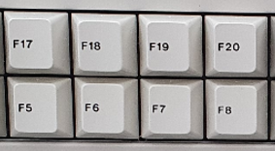 | r08 rF0 r08 | r10 rF0 r10 | r18 rF0 r18 | r20 rF0 r20
 | r03 ^[[15~rF0 r03 | r0B ^[[17~rF0 r0B | r83 ^[[18~rF0 r83 | r0A ^[[19~rF0 r0A

right
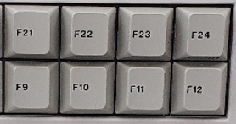 | r28 rF0 r28 | r30 rF0 r30 | r38 rF0 r38 | 5A r40 rF0 r40
 | r01 ^[[20~rF0 r01 | r09 rF0 r09 | r78 rF0 r78 | r07 ^[[24~rF0 r07

