Cherry G80-2551 ** updated 2020-04-26
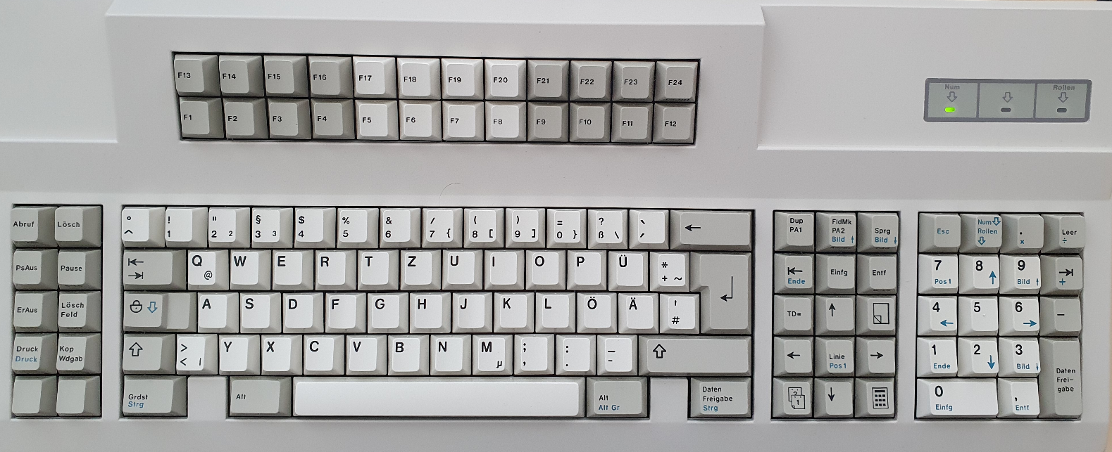
10 function keys on left cluster
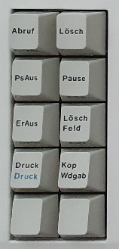 | Hid_listen:  At first press:  r19 rF0 r19  The mute/unmute toggles back and forth (on/off)  Second key press:  r19 rF0 !CS2_F0!  I60737 X61239 r19 W61240 R61741 wF2 rFA rAB r86 ID:AB86(2)  S61747 wED rFA w02 rFA L61754  Xev:  No output, key press does not do anything to xev | r5F rF0 r5F  KeyRelease event, serial 38, synthetic NO, window 0x5e00001,  root 0x1da, subw 0x0, time 5871881, (-353,153), root:(508,608),  state 0x10, keycode 202 (keysym 0x0, NoSymbol), same_screen YES,  XLookupString gives 0 bytes:  XFilterEvent returns: False
 | r39 rF0 r39  The vol + repeats automatically until full volume  Xev:  No output, key press does not do anything to xev | rE1 r14 r77 rE1 rF0 r14 rF0 r77  KeyPress event, serial 38, synthetic NO, window 0x5e00001,  root 0x1da, subw 0x0, time 6177324, (284,191), root:(1145,646),  state 0x10, keycode 127 (keysym 0xff13, Pause), same_screen YES,  XLookupString gives 0 bytes:  XmbLookupString gives 0 bytes:  XFilterEvent returns: False
 | First key press:  r53 rF0 r53  r5C rF0 r5C  Second key press:  r53 rF0 !CS2_F0!  I35522 X36023 r53 W36025 R36526 wF2 rFA rAB r86 ID:AB86(2)  S36532 wED rFA w02 rFA L36539  Xev:  FocusIn event, serial 35, synthetic NO, window 0x5e00001,  mode NotifyUngrab, detail NotifyAncestor  KeymapNotify event, serial 35, synthetic NO, window 0x0,  keys: 2 0 0 0 0 0 0 0 0 0 0 0 0 0 0 0  0 0 0 0 0 0 0 0 0 0 0 0 0 0 0 0 | r50 rF0 r50  FocusIn event, serial 35, synthetic NO, window 0x5e00001,  mode NotifyUngrab, detail NotifyAncestor  KeymapNotify event, serial 35, synthetic NO, window 0x0,  keys: 2 0 0 0 0 0 0 0 0 0 0 0 0 0 0 0  0 0 0 0 0 0 0 0 0 0 0 0 0 0 0 0
 | rE0 r12 rE0 r7C rE0 rF0 r7C rE0 rF0 r12  EnterNotify event, serial 38, synthetic NO, window 0x5c00001,  root 0x1da, subw 0x0, time 6509804, (172,102), root:(1033,557),  mode NotifyNormal, detail NotifyAncestor, same_screen YES,  focus YES, state 16  KeymapNotify event, serial 38, synthetic NO, window 0x0,  keys: 75 0 0 0 0 0 0 0 0 0 0 0 0 0 0 0  0 0 0 0 0 0 0 0 0 0 0 0 0 0 0 0 | r6F rF0 r6F  on second key press I get often  r6F rF0 !CS2_F0!  I62585 X63087 r6F W63088 R63589 wF2 rFA rAB r86 ID:AB86(2)  S63594 wED rFA w02 rFA L63602  Xev:  No output
 | r5C rF0 r5C  The win/menu key seems to repeat endless; if I press d after this key, desktop is shown like win+d  FocusIn event, serial 35, synthetic NO, window 0x5600001,  mode NotifyUngrab, detail NotifyAncestor  KeymapNotify event, serial 35, synthetic NO, window 0x0,  keys: 2 0 0 0 0 0 0 0 0 0 0 0 0 0 0 0  0 0 0 0 0 0 0 0 0 0 0 0 0 0 0 0 | r48 rF0 r48  FocusIn event, serial 35, synthetic NO, window 0x5600001,  mode NotifyUngrab, detail NotifyAncestor  KeymapNotify event, serial 35, synthetic NO, window 0x0,  keys: 2 0 0 0 0 0 0 0 0 0 0 0 0 0 0 0  0 0 0 0 0 0 0 0 0 0 0 0 0 0 0 0

