Cherry G80-2551 ** updated 2020-04-26 Version 2
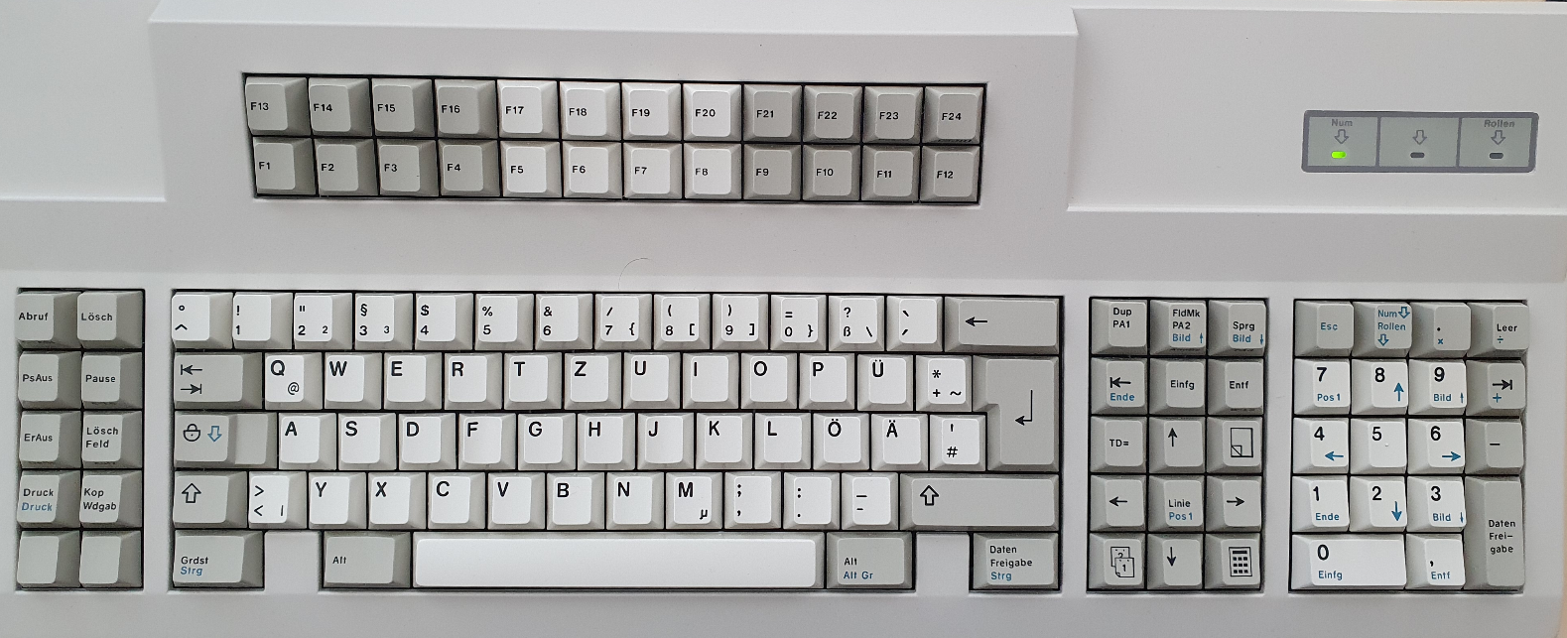
Note: starting hid_listen often leads to the following behavior:
sudo ./hid_listen
[sudo] password for <<user>>:
Waiting for device:
Listening:
rF0 r5A
hid_listen starts with “rF0 r5A” although I have not pressed a key so far; seems like a “hang-over”

For 10 function keys on left cluster, hid_listen for left 5 keys, labeled: Abruf=row1, PsAus=row2, ErAus=row3, Druck=row4, blank=row5.
Output is for pressing keys ~5 times per second.
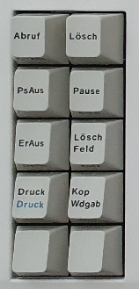 | r19 rF0 r19 r19 rF0 !CS2_F0!  I25553 X26054 r19 W26055 r19 W26057 rF0 W26059 R26060 wF2 rFA rAB r86 ID:AB86(2)  S26066 wED rFA w02 rFA L26074 r19  key loops (mute on / off); unplug USD, replug
r39 rF0 r39 r39 rF0 !CS2_F0!
I64602 X65103 r39 W65104 r39 W65106 rF0 W65108 R65108 wF2 rFA rAB r86 ID:AB86(2)
S65115 wED rFA w02 rFA L65122 r39

key loops (mute on / off); unplug USD, replug

r53 rF0 r53 r53 rF0 !CS2_F0!
I21197 X21699 r53 W21700 R22201 wF2 rFA rAB r86 ID:AB86(2)
S22207 wED rFA w02 rFA L22214 r53 rF0 r53 r53 rF0 !CS2_F0!
I23795 X24297 r53 W24298 R24799 wF2 rFA rAB r86 ID:AB86(2)
S24804 wED rFA w02 rFA L24812 r53 rF0 r53 r53 rF0 !CS2_F0!
I25812 X26313 r53 W26315 r53 W26317 rF0 W26319 R26319 wF2 rFA rAB r86 ID:AB86(2)
S26325 wED rFA w02 rFA L26333 r53 r53 rF0 r53 r53 rF0 !CS2_F0!
I26355 X26857 r53 W26858 r53 W26860 rF0 W26862 R26863 wF2 rFA rAB r86 ID:AB86(2)
S26869 wED rFA w02 rFA L26877 r53 r53 rF0 r53
rE0 r12 rE0 r7C rE0 rF0 r7C rE0 rF0 r12 rE0 r12 rE0 r7C rE0 rF0 r7C rE0 rF0 r12 rE0 r12 rE0 r7C rE0 rF0 r7C rE0 rF0 r12

- Works!
r5C rF0 r5C r5C rF0 !CS2_F0!
I30495 X30997 r5C W30998 R31499 wF2 rFA rAB r86 ID:AB86(2)
S31505 wED rFA w02 rFA L31512 r5C rF0 r5C r5C rF0 !CS2_F0!
I35300 X35801 r5C W35802 R36304 wF2 rFA rAB r86 ID:AB86(2)
S36309 wED rFA w02 rFA L36317

- Key opens menu for every ~third key press
- Menu key keep looping (letting the key go, wait, press d = minimize to desktop); unplug USD, replug

General: Starting hid_listen and plugging in the Teensy shows:
Waiting for device:......
Listening:

TMK:ed03fb67+/LUFA

USB configured.

Keyboard start.
I421 X922 rAA W923 R1424 wF2 rFA rAB r86 ID:AB86(2)
S1429 wED rFA w02 rFA L1436

