Cherry G80-2551 ** updated 2020-04-26 Version 3
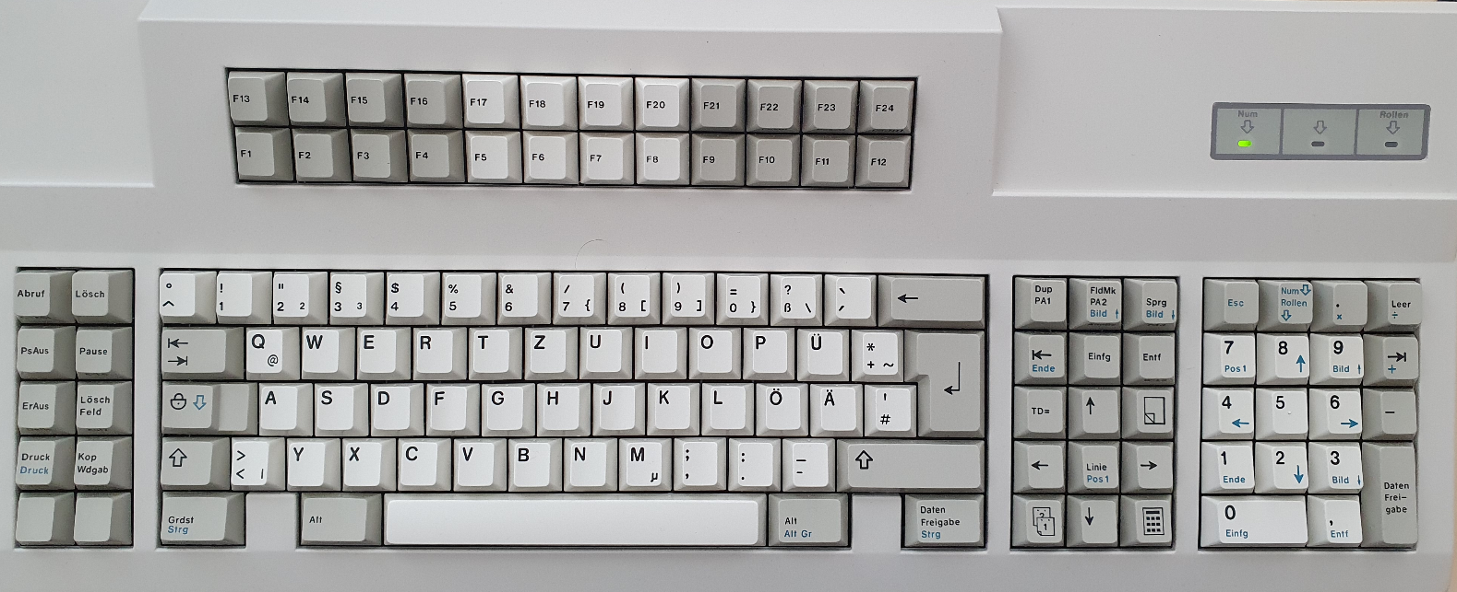

For 10 function keys on left cluster, hid_listen and xev:
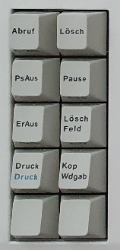 | Mute  r19 rF0 r19  MappingNotify event, serial 42, synthetic NO, window 0x0,  request MappingKeyboard, first_keycode 8, count 248 | (no key)  r5F rF0 r5F  no xev output
 | Vol+  r39 rF0 r39  MappingNotify event, serial 44, synthetic NO, window 0x0,  request MappingKeyboard, first_keycode 8, count 248 | (no key)  rE1 r14 r77 rE1 rF0 r14 rF0 r77  no xev output
 | Vol –  r53 rF0 r53  MappingNotify event, serial 46, synthetic NO, window 0x0,  request MappingKeyboard, first_keycode 8, count 248 | Mouse?  r50 rF0 r50  no xev output
 | Print Screen  rE0 r12 rE0 r7C rE0 rF0 r7C rE0 rF0 r12  no xev output | Properties  r6F rF0 r6F  no xev output
 | Menu  r5C rF0 r5C  no xev output | Mouse x?  r48 rF0 r48  no xev output

Nav cluster – all keys show xev output (not shown here)
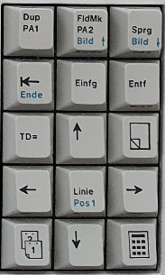
r17 /rF0 r17 | rE0 r12 rE0 ^[[5~r7D rE0 rF0 r7D rE0 rF0 r12 | rE0 r12 rE0 ^[[6~r7A rE0 rF0 r7A rE0 rF0 r12
rE0 r12 rE0 r69 ^[[FrE0 rF0 r69 rE0 rF0 r12 | rE0 r12 rE0 ^[[2~r70 rE0 rF0 r70 rE0 rF0 r12 | rE0 r12 rE0 r71 ^[[3~rE0 rF0 r71 rE0 rF0 r12
r80 r26 r80 rF0 r26 | rE0 r12 rE0 r7^[[A5 rE0 rF0 r75 rE0 rF0 r12 | r80 r25 #r80 rF0 r25
rE0 r12 rE0 r^[[D6B rE0 rF0 r6B rE0 rF0 r12 | rE0 r12 rE0 r6C ^[[HrE0 rF0 r6C rE0 rF0 r12 | rE0 r12 rE0 ^[[Cr74 rE0 rF0 r74 rE0 rF0 r12
r80 r16 r80 rF0 r16 | rE0 r12 rE0 r72 ^[[BrE0 rF0 r72 rE0 rF0 r12 | r80 r1E r80 rF0 r1E

Working with the current layout shows that changing the arrow keys to inverted T would be a very good option (arrow right, up and left one key down)

F-block – all keys show xev output (not captured here)
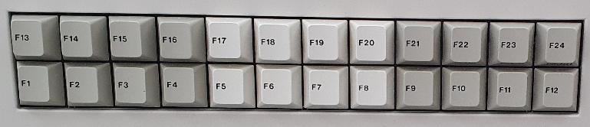
left
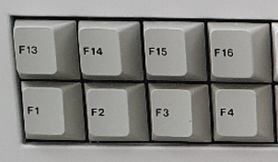 | r1F rF0 r1F | r27 rF0 r27 | r2F rF0 r2F | r5E rF0 r5E
 | r^[OP05 rF0 r05 | r06 ^[OQrF0 r06 | r^[OR04 rF0 r04 | r0C ^[OSrF0 r0C

middle
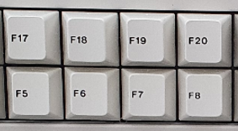 | r08 rF0 r08 | r10 rF0 r10 | r18 rF0 r18 | r20 rF0 r20
 | r03 ^[[15~rF0 r03 | r0B ^[[17~rF0 r0B | r83 ^[[18~rF0 r83 | r0A ^[[19~rF0 r0A

right
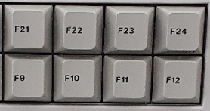 | r28 rF0 r28 | r30 rF0 r30 | r38 rF0 r38 | r40 rF0 r40
 | r01 ^[[20~rF0 r01 | r09 rF0 r09 | r78 rF0 r78 | r07 ^[[24~rF0 r07

Num pad
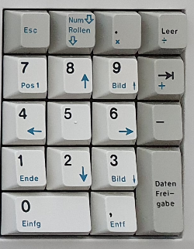 | r^[76 rF0 r76 | r7E rF0 r7E | r7C *rF0 r7C | rE0 r4A /rE0 rF0 r4A
 | r6C 7rF0 r6C | r75 8rF0 r75 | r7D 9rF0 r7D | r+79 rF0 r79
 | r46B rF0 r6B | r73 5rF0 r73 | r74 6rF0 r74 | r7B -rF0 r7B
 | r169 rF0 r69 | r272 rF0 r72 | r7A 3rF0 r7A | rE0 r12 rE0 r5A  rE0 rF0 r12 rE0 rF0 r5A
 | r070 rF0 r70 |  | r71 ,rF0 r71 | rE0 r12 rE0 r5A  rE0 rF0 r12 rE0 rF0 r5A

Remark: ESC works as expected, NUM/Scrol lock does not; xev reports:

KeyRelease event, serial 38, synthetic NO, window 0x6000001,
root 0x1da, subw 0x0, time 2706758, (-25,174), root:(836,629),
state 0x10, keycode 78 (keysym 0xff14, Scroll_Lock), same_screen YES,
XLookupString gives 0 bytes:
XFilterEvent returns: False

