Cherry G80-2551 ** updated 2020-04-27 (scan code set 3)
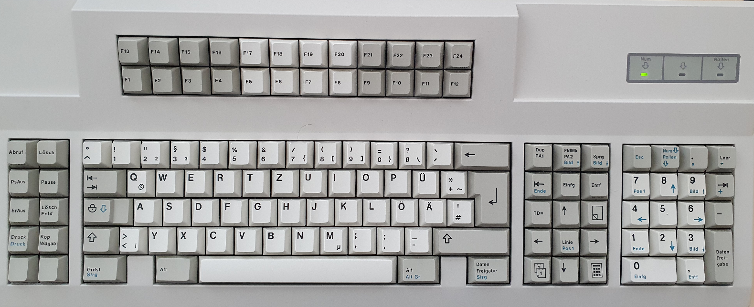
Start of hid_listen:
Waiting for device:.....
Listening:
TMK:e0236e64+/LUFA
USB configured.
Keyboard start.
I420 wED rFA w02 rFA X922

For 10 function keys on left cluster, hid_listen:

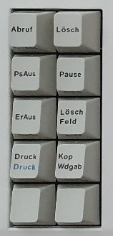 | r05 rF0 r05 | r06 rF0 r06
 | r04 rF0 r04 | r0C rF0 r0C
 | r03 rF0 r03 | r0B rF0 r0B
 | r83 rF0 r83 | r0A rF0 r0A
 | r01 rF0 r01 | r09 rF0 r09

Nav cluster
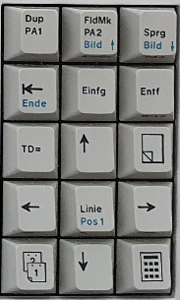 | r67 /rF0 r67 | r6E ^[[5~rF0 r6E | r^[[6~6F rF0 r6F
 | r64 ^[[FrF0 r64 | r65 ^[[2~rF0 r65 | r6D ^[[3~rF0 r6D
 | r80 !CS3_READY!  r26 3r80 !CS3_READY!  rF0 r26 | r63 ^[[ArF0 r63 | r80 !CS3_READY!  r25 4r80 !CS3_READY!  rF0 r25
 | r61 ^[[DrF0 r61 | r62 ^[[HrF0 r62 | r6A ^[[CrF0 r6A
 | r80 !CS3_READY!  r116 r80 !CS3_READY!  rF0 r16 | r^[[B60 rF0 r60 | r80 !CS3_READY!  r1E 2r80 !CS3_READY!  rF0 r1E

F-block – all keys show xev output (not captured here)
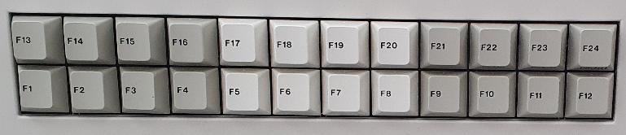
Left F1-F4 & F13-F16
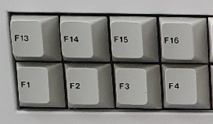 | r08 rF0 r08 | r10 rF0 r10 | r18 rF0 r18 | r20 rF0 r20
 | r0^[OP7 rF0 r07 | r0F ^[OQrF0 r0F | r17 ^[ORrF0 r17 | r1F ^[OSrF0 r1F

Middle F5-F8 & F17-F20
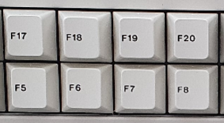 | r28 rF0 r28 | r30 rF0 r30 | r38 rF0 r38 | r40 rF0 r40
 | r27 ^[[15~rF0 r27 | r2^[[17~F rF0 r2F | r^[[18~37 rF0 r37 | r3F ^[[19~rF0 r3F

Right F9-F12 & F21-F24
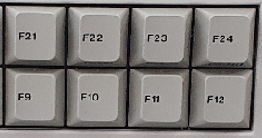 | r48 rF0 r48 | r50 rF0 r50 | r57 rF0 r57 | r5F rF0 r5F
 | r^[[20~47 rF0 r47 | r4F rF0 r4F | r56 rF0 r56 | r^[[24~5E rF0 r5E

Num pad
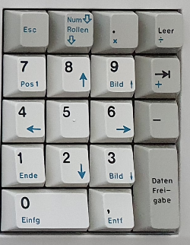 | r76 ^[rF0 r76 | r77 rF0 r77 wED rFA w00 rFA | r7E rF0 r7E | r84 *rF0 r84
 | r6C ^[[HrF0 r6C | r75 ^[[ArF0 r75 | r7D ^[[5~rF0 r7D | r7C +rF0 r7C
 | r^[[D6B rF0 r6B | r73 ^[[ErF0 r73 | r74 ^[[CrF0 r74 | r7B -rF0 r7B
 | r69 ^[[FrF0 r69 | r72 ^[[BrF0 r72 | r^[[6~7A rF0 r7A | r79  rF0 r79
 | r70 ^[[2~rF0 r70 |  | r71 ^[[3~rF0 r71 | r79  rF0 r79

